Harmonization of Research Ethics Board (REB) review is usually triggered by the following:
1. Firstly, RISe detects multiple REBs as per sites listed in Application Boxes 4.2A and 4.2B.
RISe automatically pulls the profiles of the PI and CO-Investigators to be listed as study sites, so if the Health Authority (HA) is listed in their profile it will automatically populate in Boxes 4.2A, 4.2B and 4.2D.

If this happens then you will see this on the study homepage
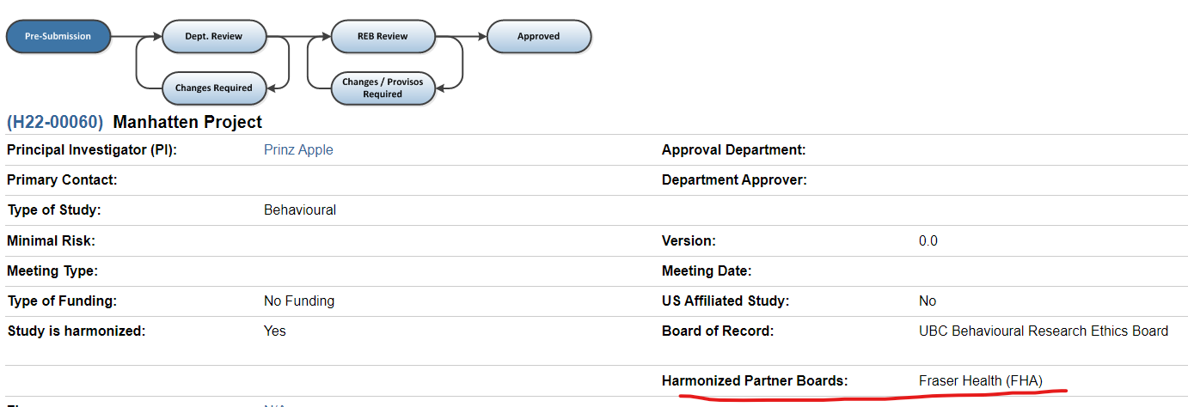
If the study has nothing to do with the HA (no staff, facilities, data, resources) and the individual is not conducting research under the auspices of the HA (eg, will not publish under there HA affiliation) then there is typically no need to have the HA REB review.
a) Study team should manually remove that site(s) listed in 4.2A or 4.2B (Box 4.2D will auto update) OR they can clearly indicate in box 4.2C textbox that no HA staff, facilities, data, resources used and Study team is not conducting research under the auspices of the HA and the REB may instruct them to update Boxes 4.2A or 4.2B.

2. Secondly, REB staff will flag an application for harmonization if HA sites (FH, IH, VIHA, NH) or other BC universities/colleges are listed in other locations of the application
OR
3. Subsequently, if a team member has a HA/other university email listed noticed by REB staff

The above 3 scenarios are typically what trigger harmonized REB review.

